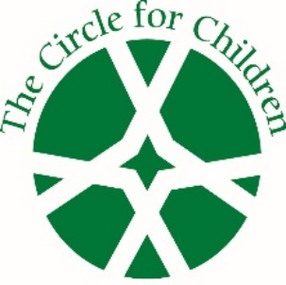

The Circle for Children is reported to be the longest running women’s charity for children in the state of Georgia. Operating continuously since 1927, we have a rich tradition of financial giving and personal encouragement to disadvantaged youth throughout metro Atlanta and Georgia.
- This 100% volunteer organization has contributed millions of dollars in aid and scholarships, as well as countless hours of hands-on service to youth who have suffered abuse, neglect and abandonment.
- The monetary donations we provide help fill the gap between government and civic funding.
- Our leaders organize fundraising events and charitable efforts as well as social gatherings to forge long term bonds among the membership – enhancing the Circle’s outstanding history and legacy.
- The Circle is a registered 501(c)3 organization.

We need your help to raise funds for our beneficiary!
In Atlanta

WHY YOUR SUPPORT MATTERS

- City of Refuge is celebrating 26 years of providing transitional housing for women and their children coming out of crisis in one of the most crime ridden zip codes in Atlanta.

- City of Refuge also provides daycare, preschool, after school programs, psychological & therapeutic services, plus medical care & on-site school, all under one roof.

- City of Refuge’s comprehensive approach helps to break the cycle of poverty, homelessness, and abuse that are too common in historically marginalized.
and economically disadvantaged communities.

